**8-BIT MULTIPLICATION**  
  
  
**EXP NO: 3**  
  
 **AIM:**

To write an assembly language program to  
implement 8-bit multiplication using 8085 processor.  
  
**ALGORITHM:**

1)      Start  
the program by loading a register pair with the address of memory location.  
2)      Move  
the data to a register.  
3)      Get  
the second data and load it into the accumulator.  
4)      Add  
the two register contents.  
5)      Increment  
the value of the carry.  
6)      Check  
whether the repeated addition is over.  
7)      Store  
the value of product and the carry in the memory location.  
8)      Halt.  
  
  
   
  
  
**PROGRAM:**  
LDA 8500  
MOV B, A  
LDA 8501  
MOV C, A  
CPI 00  
JZ LOOP  
XRA A  
LOOP1: ADD B  
DCR C  
JZ LOOP  
JMP LOOP1  
LOOP: STA 8502  
RST 1       
  
  
  
  
  
  
  
  
**INPUT:**  
  
  
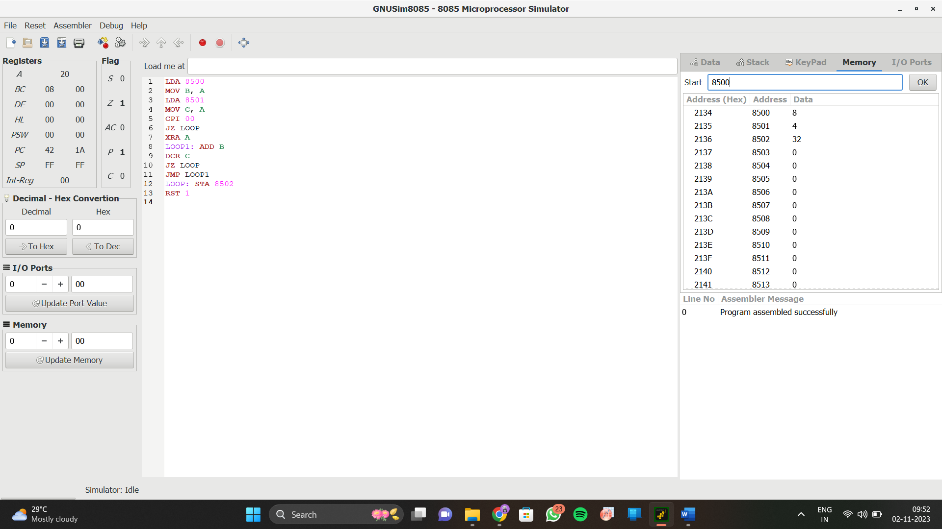

**OUTPUT:**

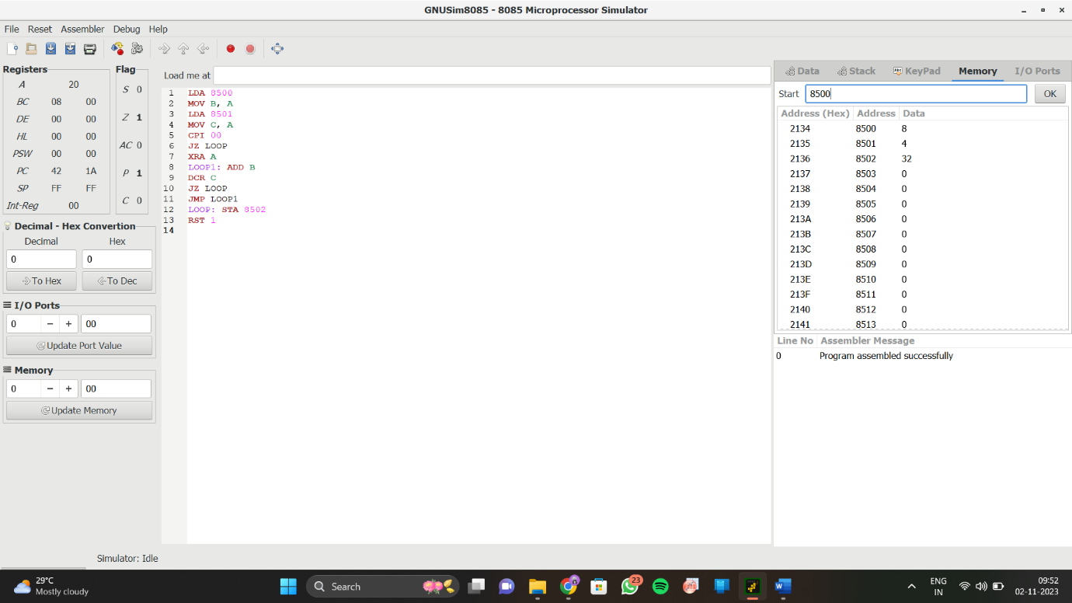  
  
  
   
  
  
 

**RESULT:**

Thus the program was executed successfully  
using 8085 processor simulator.